Don Pedro Mexican Restaurant
25th Annual “Friends of the Cowboys”

Golf Tournament

To Benefit the McCollum High School
Scholarship Fund & Athletic Department

Friends of the Cowboys, A 501(c) (3) Non-Profit Organization

Golf Club of Texas

Friday April 26, 2024
Registration—11:00AM Shotgun Start—1 PM

Cowboy Sponsor $675.00

Tee Sponsor, 4-Players

Green & Gold Sponsor $380.00

Tee Sponsor, 2-Players

Tee Sponsor $100.00

Individual Players $150.00

Entry fee includes LUNCH & DINNER, SHIRT, HAT,
2 MULLIGANS, SLEEVE Golf BALLS.

Format: 4 PERSON--FLORIDA SCRAMBLE

1st & 2nd Low Gross & Net

On Course Contests

NAME______________ SHIRT SIZE _____
NAME______________ SHIRT SIZE _____
NAME______________ SHIRT SIZE _____ NAME______________ SHIRT SIZE _____

NOW ACCEPTING PAYPAL-THRU OUR WEBSITE
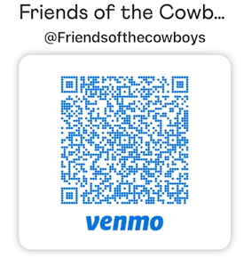
SCAN HERE to pay via VENMO:

WWW.FRIENDSOFTHECOWBOYS.ORG
VISA & MASTERCARD ACCEPTED
THE DAY OF THE EVENT
MAIL ENTRY FORM AND CHECKS TO:
Ray Byars
1803 Archers Bow
San Antonio, TX 78232
Make check payable to: “Friends of the Cowboys”

For information call:

Ray Byars 210-394-4942 Geoff Boggess 210-878-9725
Bill Hall 210-744-3900 Leroy Seidel 830-237-4181

